Course Work Cover Sheet - The School of Computing

Author’s Name: Kyle Harrison; Richard Dowdalls; Toby Philp; Daniel Joyce

Matriculation
Numbers: 110009870; 090004575; 050005919; 100016064

Module Code: AC21003

Assignment Title: AC22003.2 Human Computer Interaction

Date Submitted: 30/03/12

Date Due to be
Submitted: 30/03/12

Word Count

Your course work may be used by The School of Computing for demonstration purposes with other classes and/or members of the public, unless you indicate otherwise. Tick the box at the right if you do not wish your work to be used in this way. | ❒

I certify that this assignment represents all my own work and that no parts of it have been copied and that no collusion has taken place with any other person. I have also read and understood The School of Computing’s regulations as regards course work and I certify that this course work was performed according to those regulations.

I certify that any disks submitted with this assignment have been virus checked and have no viruses on them.

Signed: ………….…..<Name>

User-centred design for MMVT web interface tool

Introduction

Motor / Mobile vehicle technicians (MMVT) have been an independent mobile motor mechanics in Dundee since 2009. Their base of operations which is their garage is located in Dundee. Their client base of customers covers all of Dundee and its surrounding areas. The two owners of MMVT are the only vehicle technicians that operate within the business and they share a combined experience of 20 years as car mechanics in the motor trade.

Summary of contents:
- Background research
- Persona's
- Scenarios of use
- Current Systems
- Requirements definition
- User centred design plans

Background Research
In the context of user centred design the users of the system will be customers using the web tool offered by MMVT alongside the owners of the business who are additionally the primary stakeholders that will be using the system to store information regarding customers, vehicles, and repairs.
The intended users of the system will include both owners of MMVT who assume the role administrators in the system and any customers who wish to engage in their services as users of the system. Once a user registers on the system they instantly become a user resulting in only 2 set’s of users to the system.
For this reason the 2 sets of users interacting with the system results in 2 different usage environments to be considered. Gathering information and resources regarding the usage environment of the system from the perspective of MMVT garage will be simpler than identifying the usage environment of every single user that wishes to register as a customer on the website. Therefore some assumptions will be made based on the usage environment of the user based on the model of current systems, best practices, and feedback from the stakeholders.
MMVT
MMVT operate on a rota of 8am to 6pm from Monday to Saturday and Sundays by appointment only. During their hours of operating they offer repairs, maintenance, and MOTs on a variety of vehicle ranging from scooters to large vans. They specialise in roadside repairs of vehicles that have broken down and need assistance either by the roadside or at an address provided by the customer. MMVT provide a priority response to vehicles that have broken down but the response is based on the availability of one of the mechanics.

Customers
Customers will be anyone that is in need of one or more of the services that MMVT offers. They become customers upon first contact with of the owners of the business and their details are given either by telephone, in person or their online contact form. Customers come from Dundee and the surrounding area’s with different levels of priority depending on their circumstances. Customers in need of roadside response are high priority customers that get first response based upon availability of a technician being available. Followed by customers that made appointments who receive a medium priority. These medium priority customers are those that can wait to have their vehicle seen by a technician but require it to be done on the time allocated in the appointment. Last of all customers who do not need roadside assistance and do not have an appointment but still need their vehicle seen to by a technician will be given a low priority which will result in them being given an appointment and moving up to medium priority when the appointment is confirmed.

MMVT and Customer Needs
MMVT need the system to include an online booking database where customers can enter their details (car registration number, description of problem, and their personal details). They require a website that their customers can access and the website should have an area where they can enter the information outlined above.

If an existing customer returns, both MMVT and their customer should be able to view details of previous work that has been done on the vehicle. The system doesn’t need to include parts management or stock control. MMVTs customers should have access to the details of the work which is being carried out on their vehicle. The system should have a login area where the customer can view details on their vehicle.

System:
- Requires a database to store customer information
- Requires a website that customers can access
- Website should allow users to display and print account information
- MVT should be able to alter or remove data where necessary
- Website needs to be accessible in different browsers
- The website should have a page where customers can enter their information

How do we use this information to generate alternative designs?
We use this information to generate alternative designs by evaluating the current design based on the requirements and making modifications to the design that will make system more user friendly in line with the requirements, this could lead to alternative designs being created. The users being the customer to MMVT and the client (the owners of MMVT).

How do we choose from these alternatives?
Through testing and evaluation of the designs, we can make a decision on the design to use.

Persona’s

Persona: Customer

The Customer persona represents a generic customer who approaches the company via the website.
Location: Dundee (approximate area).
Gender: Male/ Female
Age: Age 16 + for Scooter/Motorcycle Repairs
Age 18+ for Motor vehicle Repairs

Description: The customer will usually be a driver who owns a vehicle. They do not have a mechanical background or may have a very limited mechanical knowledge. They require repair or service work to be carried out on their vehicle.

We assume that a general customer will unlikely have a technical background, however a customer who chooses to approach the company via the website rather than other available methods (in person...) will highly likely be familiar with web browsing and navigating hypertext pages and feel comfortable with basic web feature concepts.
The customer may have different technologies available to them, however it is known they have some form of internet access which is typically expected to be from their home or work environment.

In approaching MMVT the customer wants or aims for the following:
- To be confident in the work being carried out.
- The work to be (in most cases) done ASAP (fast response)
- Fair pricing
- To feel like they can rely on the business
- To be clearly informed.
- To be recognized/rewarded for loyalty.
- A full range of services (doesn’t want to have to seek different businesses for individual tasks).
- No worries (to feel like everything is taken care of)
- To feel the business/mechanics are approachable.
- An estimate of time/price before making a commitment.

Persona: Business Partner

The Business Partner persona represents a generic persona of both partners of the business..
Age:
25-30 approx
Location:
Dundee
Background:
Mechanics
Gender: Male
Time invested in the business:
18 Months
Working hours:
8-6 Monday to Friday, sometimes will do extra work on Saturdays, appointment only on Sundays.

Current Hardware:
Technology 1 PC running windows XP, appears > 5 years old and is unlikely to be up to date. The PC is used to maintain customer history information and to respond to email inquiries. Other technology and current systems are paper based primarily in the form of a log book.

Description of needs:
Business partner will record information customers give them or about work carried out using systems (mentioned previously) in the work environment. Commonly they would do this either on the phone or between repair tasks.

Summary of day to day activities
The business partner performs a wide range of tasks within the business. The tasks identified are (but not necessarily limited to):
- Repair work
- Customer service tasks
- Schedule appointments with customers (through phone, email or in person).
- Make call-outs to customers (e.g. breakdowns or at home repairs).
- Record customer and vehicle details in logbook/on current system.
- Participate in business promotion and marketing activities.
- Undertake restoration and upgrade projects.
- Document repair work.
- Some vehicle and parts sales.
- Process customer invoices/receipts.
- Update customer database.
- Inventory/stock management.

Scenarios

Scenario 1 – Customer car breakdown
John is driving his car along a busy road when his engine suddenly stalls causing him to breakdown along the roadside. In a panic he turns on his hazard lights to alert the traffic quickly building up in the road his car has broken down and cannot move it. John has no knowledge of motor vehicles or the cause of the problem and is helpless to resolving and repairing the problem himself.
He then recalls that the telephone number of a local repair garage that performs call outs in these situations is on his mobile. John places the call to “Motor Vehicle Technicians” explaining the situation in which he broke down and the urgency of the situation. The business owner on the other end of the phone requests his personal information (Name, registration, and other details) alongside his current location. Once the information has been exchanged and recorded John is told approximately how long it will take for a mechanic to reach him on the roadside and awaits the arrival. To the relief of John the mechanic arrives promptly and after confirming the details of the problem the mechanic starts to repair the engine by the roadside and moments later John is on the road driving his car again.

Scenario 2 – Customer Appointment
Ian is busy in the garage working on a repairing a customer’s car that has broken down on the roadside. The car requires a computer diagnostic to identify the problem and the repair will most likely take the remainder of the day. Suddenly the phone rings and as the only person in the garage he has to stop what he is doing to answer the call.

When he answers the call he discovers that the customer on the other end is rather frustrated because his VW Passat would not start that morning after a night of heavy frost despite having no previous problems with it. The customer says he lives in Dundee and asks if anyone can come out to repair it. Ian checks the diary quickly and explains that there is no one able to come out immediately however he would be able to send his partner to investigate the problem in approximately an hour’s time when he returns to the garage from a roadside repair that has just been completed. The customer is happy with waiting for his appointment as he is currently at home as has no immediate need to leave so Ian takes the name, contact number and address of the customer and enters it in the dairy. He briefly explains that the mechanic coming to perform the repair will make a call to the number given when he is at the scene and the repair will be carried out in the comfort of the customer’s home.

Current Systems

Evaluation of the current systems will begin with the current system which MMVT use. This is a receipt system which stores details of the vehicle that has been repaired, and the work that has been done on the vehicle. The current system allows MMVT to store details on any vehicle which has had repairs. But it is not part of a website and therefore there is no function for customers to MMVT to enter their own information.
The requirements outlined by MMVT include a website which allows their customers to send details of the problem which they have with their vehicle, the information on MMVTs customers will be stored in a database which the owners of MMVT will have access to.

Figure 1 – Web interface
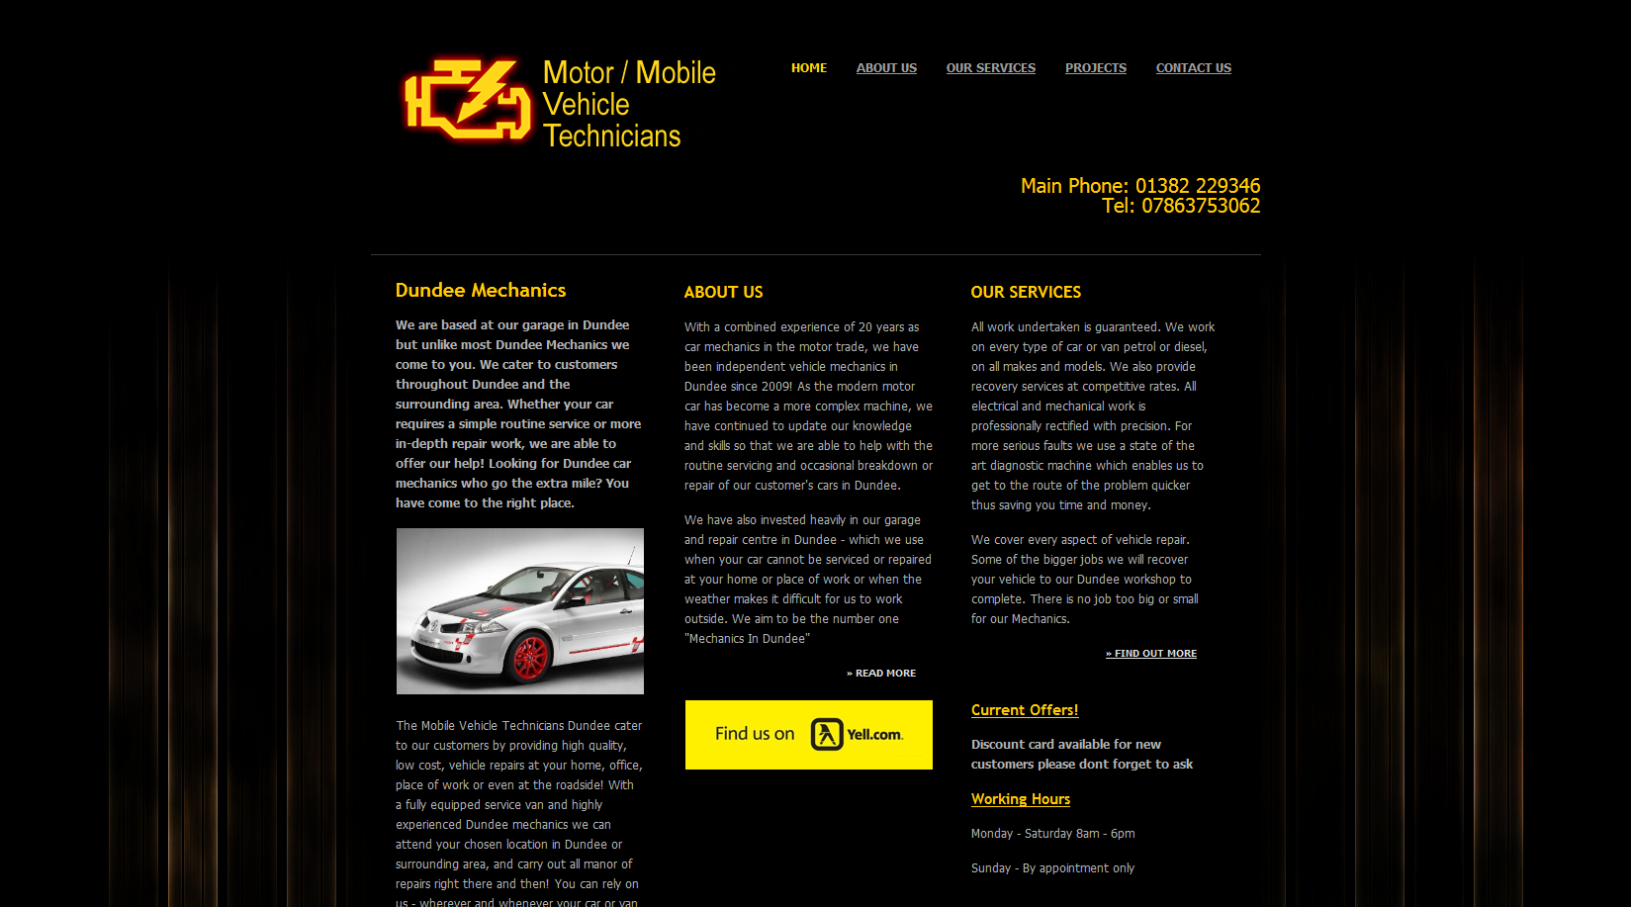

Figure 2 – Receipt Interface.
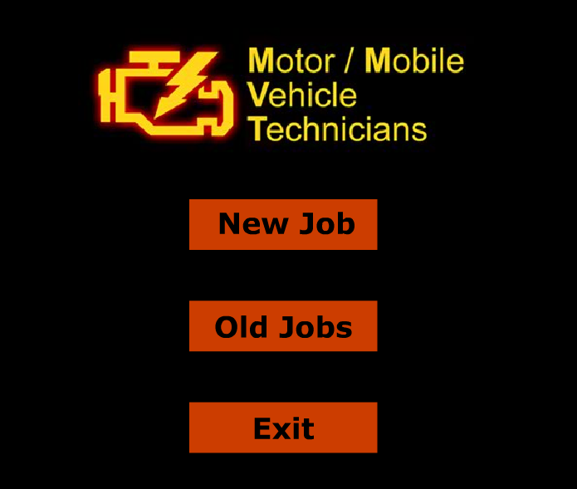
Figure 3 – Job Search Form
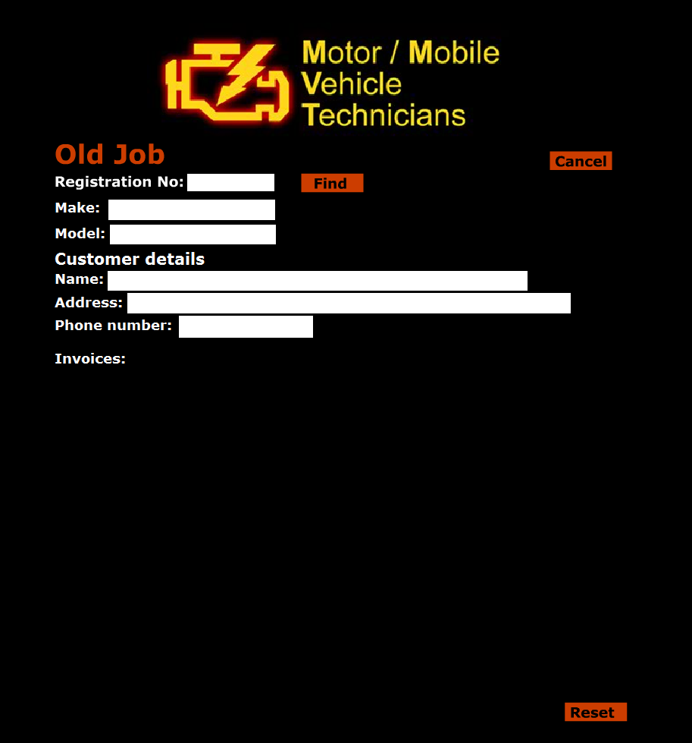

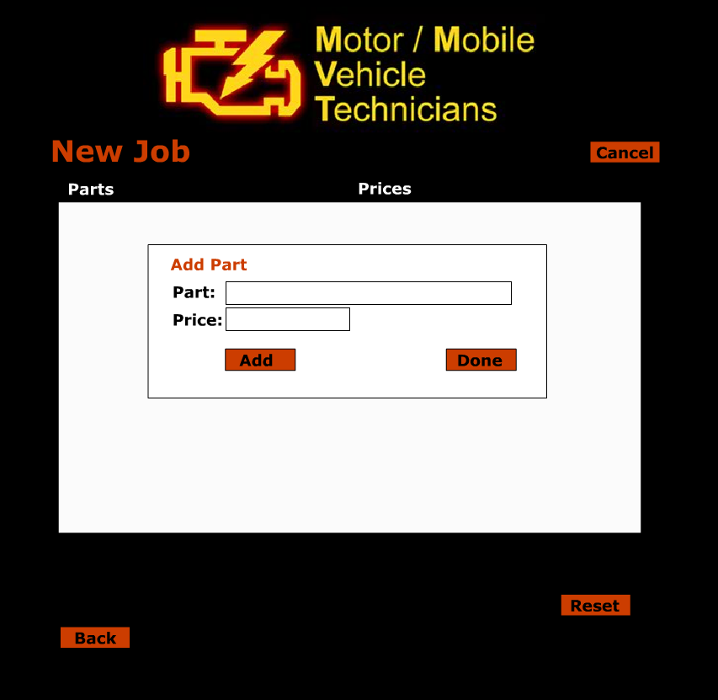

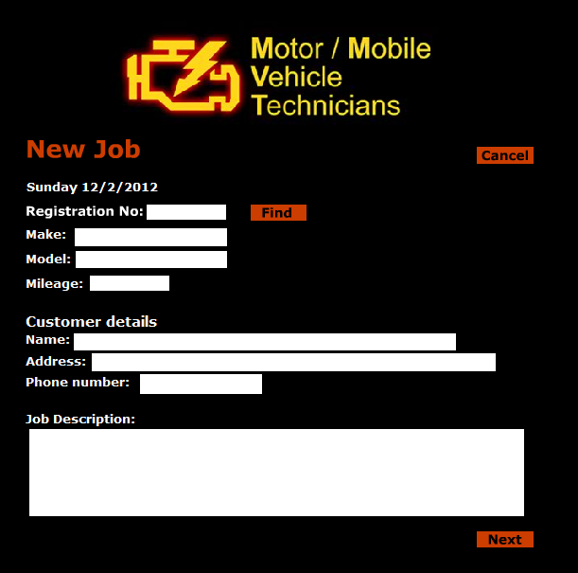

Competitors Systems

Your garage online essentially offers the same functionality that MVT require with the exception that MVT will be carrying out the work that will be stored in the system alongside granting them direct control of customer accounts to update and edit these instead of the use doing it manually. What your garage online does is :

- help you manage everything from your vehicle's routine maintenance to those major and minor repairs
- Staying informed of your vehicle's service history will help you take better care of your worst investment.

http://yourgarageonline.com/

- User is presented with a splash screen allowing them to either log in or register to the system
- User who selects register is presented with a registration form in which they must complete to create a customer account
- Vehicle registry form is then presented to the user requesting necessary vehicle information followed by optional information
- The car will then be created an added to the system and the user will be shown these details to confirm are correct. In the event that they are not correct then they can choose to edit the details.
- Users can select

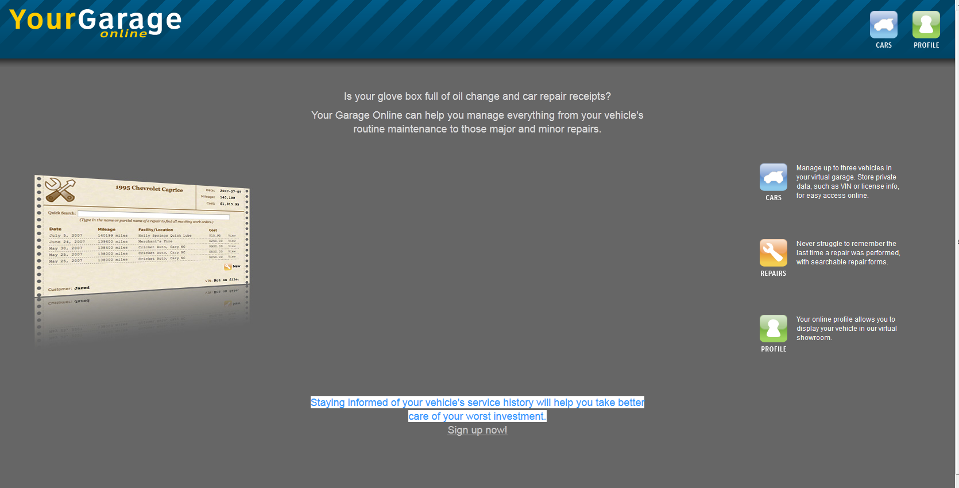

Sign up

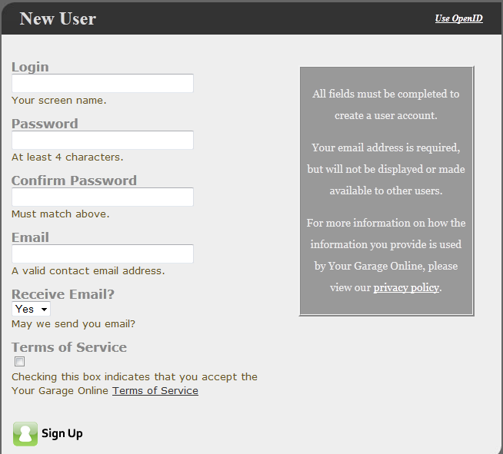

Login
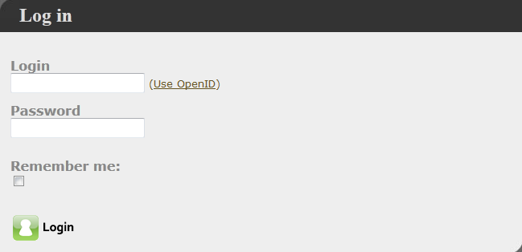

Vehicle Registration
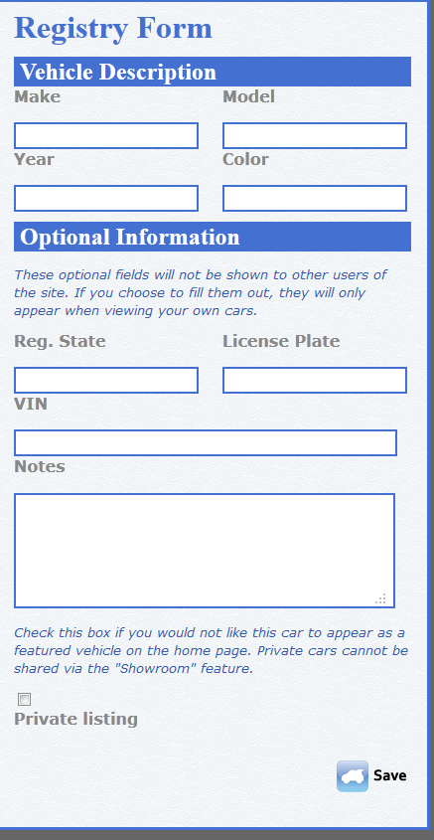

Functional Requirements

The functional requirements consist of Business functional requirements and customer functional requirements. The list below shows the requirements in each section.

Business functional requirements
R1 Require a valid staff login to access staff features.
R2 Display booking requests made by customers.
R3 Allow a business user to confirm a booking request.
R4 Insertion of a booking record.
R5 Altering of a booking record.
R6 Removal of a booking record.
R7 Notify the user of booking conflicts.
R8 Display all bookings that have been made.
R9 Display all bookings for a specified single day.
R10 Display all bookings for a specified single week.
R11 Display all bookings for a specified single month.
R12 Display available times for a staff member.
R13 Filter display of booking information by staff member.
R14 Insertion of a vehicle record.R15 Altering of a vehicle record.
R15 Altering of a vehicle record.
R16 Insertion of a work history record.
R17 Altering of a work history record.
R18 Display work history records for a specified vehicle.
R19 Generate billing/receipt information based on work records.
R20 Allow entry of a customer record.
R21 Allow altering of a customer record.
Customer Functional Requirements
F22 Customer requests a booking.
F23 Booking records Customer contact details.
F24 Customer enter details about problem during booking
F25 Option to supply photos during booking.
F26 Booking requests require login or account creation to reserve booking
F27 A customer can view information held on them.
F28 A customer can edit information held on them.
F29 A customer can view their receipts for work carried out.
F30 Customer accounts shall be enforced by a login mechanism.

Business functional requirements
This section describes functional requirements for the system components that are viewed from a business perspective (staff).

R1 Require a valid staff login to access staff features.
The system shall require a valid staff login to access staff features. The system shall use a login process to restrict access to staff features and the information they give access to.

Rational: Features for business staff should be secured from the general public and customers.

R2 Display booking requests made by customers.
The system shall display booking requests made by customers. The system shall display a complete overview of unconfirmed booking requests that have been made by customers to business users.

Rational: Business staff need to be able to view booking requests made by customers in order to provide a quote and confirm the booking.

R3 Allow a business user to confirm a booking request.
The system shall allow a business user to confirm a booking request. The system shall allow a business user to confirm a booking request which will enter that booking into the system as a booking record.

Rational: There are a number of situations in which MMVT would need to contact the customer for further details before committing the booking to the schedule.

R4 Insertion of a booking record.
The system shall allow insertion of a booking record. The system shall allow a business user to insert a booking record directly.

Rational: The system should manage bookings that are made by telephone or email and need to be entered manually.

R5 Altering of a booking record.
The system shall allow a business user to alter the details held in a booking record.

Rational: Business staff will need to alter booking information if a customer phones or emails to change arrangements.

R6 Removal of a booking record.
The system shall allow a business user to remove a booking record that has been made at a previous point in time.

Rational: Staff members may at times need to manually handle cancellations.

R7 Notify the user of booking conflicts.
The system shall notify the user of booking conflicts. In such cases where bookings conflict in time and staff allocation, the system shall notify the user of the conflict.

Rational: The system should notify the user when they cause a scheduling conflict in order for them to resolve time management issues.

Justification for removal: Based on the complexity of this feature it was decided that it was potentially beyond the scope of the project and that it would likely be to the determent of other features to continue exploring this option.

R8 Display all bookings that have been made.
The system shall be able to display all bookings that have been made. The system shall be able to display an overview of all bookings that are held in the system to a business user. These will be displayed ordered by date.

Rational: Business staff will need to view their work schedule and history for administration purposes.

Justification for removal: Displaying large quantities of booking information on a single page presents a difficult to navigate information overload. Attempts to design effective views such as those used in calendars don’t fit the potentially larger quantity of information for a single day. Rather than focusing on different ways to view large amounts of information it became more realistic to focus on making it easy to navigate between smaller amounts of information as an alternative approach to solving the problem.

R9 Display all bookings for a specified single day.
The system shall be able to display all bookings for a specified single day. The system shall be able to filter and display bookings for a single selected day to a business user.

Rational: Staff need to be able to view bookings that have been made for a specific day (for example to view today’s schedule).

R10 Display all bookings for a specified single week.
The system shall be able to display all bookings for a specified single week. The system shall be able to filter and display by date order all bookings that have been made for a specified week to a business user.

Rational: Business staff at times will need to view bookings on a weekly basis in order to reschedule bookings.

Justification for removal: Displaying large quantities of booking information on a single page presents a difficult to navigate information overload. Attempts to design effective views such as those used in calendars don’t fit the potentially larger quantity of information for a single day. Rather than focusing on different ways to view large amounts of information it became more realistic to focus on making it easy to navigate between smaller amounts of information as an alternative approach to solving the problem.

R11 Display all bookings for a specified single month.
The system shall be able to display all bookings for a specified single month. The system shall be able to filter and display by date order all bookings that have been made for a specified month to a business user.

Rational: Business staff at times will need to view bookings on a monthly basis in order to reschedule bookings.

Justification for removal: Displaying large quantities of booking information on a single page presents a difficult to navigate information overload. Attempts to design effective views such as those used in calendars don’t fit the potentially larger quantity of information for a single day. Rather than focusing on different ways to view large amounts of information it became more realistic to focus on making it easy to navigate between smaller amounts of information as an alternative approach to solving the problem.

R12 Display available times for a staff member.
The system should be able to display available times for a staff member. The system should be able to show the business user times where each staff member is available thus indicating available times that they can take on new work.

Rational: This information makes it a lot easier to make new bookings with customers.

Justification for removal: Related to R7 functionality that was retrospectively considered out of scope. See R7 for further details.

R13 Filter display of booking information by staff member.
The system should be able to filter display of booking information by staff member. The system should allow filtering of booking information based on which staff member is working on each booking when displaying booking information to a business user.

Rational: For business users to manage staff commitments it may be required at times to separate the commitments of each staff member.

R14 Insertion of a vehicle record.
The system shall allow a business user to insert a vehicle record.

Rational: Not all customers of the business will come through the website, staff members will need to be able to enter information directly to support these customers without keeping a separate set of records.

R15 Altering of a vehicle record.
The system shall allow a business user to directly alter information held in a vehicle record.

Rational: Business staff shall need to update information held about vehicles they are working on.

R16 Insertion of a work history record.
The system shall allow a business user to directly insert a record of work history that is related to a specific vehicle.

Rational: Business staff will need to be able to record work they have done to a vehicle for invoicing and administrative purposes.

R17 Altering of a work history record.
The system shall allow a business user to update a work history record.

Rational: At times business staff may need to change information held about work done.

R18 Display work history records for a specified vehicle.
Business staff should be able to view a report of work history records for a specified vehicle.

Rational: Business staff may need to know details of previous work they have done on a vehicle to inform their current work.

R19 Generate billing/receipt information based on work records.
The system should generate billing/receipt information based on work records. The system should relate work records to bookings and customer records in order to generate billing and receipt information upon completion of work as marked by a business user.

Rational: The system should be able to collate the information it holds to create a bill or receipt for business staff to give to a customer.

Justification for removal: This requirement was removed as a project management decision. It is quite a large requirement and as it became clear the team were unlikely to be able to complete everything that was planned on time this feature was cut. Ideally it would be considered for future development or as an upgrade path.

R20 Allow entry of a customer record.
The system shall allow a business user to enter a customer record manually.

Rational: When handling bookings over the phone or in person business staff will need to be able to record customer details.

R21 Allow altering of a customer record.
The system shall allow a business user to alter/update a customer record to reflect changes as required.

Rational: At times business staff may need to change customer information such as their address for customers who cannot access the system online.

Customer functional requirements
This section describes functional requirements for the system components that are viewed from a customer perspective.

R22 Customer requests a booking.
The system shall allow a customer or prospective customer to make a request for a booking.

Rational: Customers being able to schedule a booking via the website is a service the business wishes to offer.

R23 Booking records Customer contact details.
When a customer requests a booking, the system shall record their contact details. When a customer requests a booking in the system, the system will be required to record their contact details and relate these to the booking itself.

Rational: If there is a problem with the booking the business may need to contact the customer.

R24 Customer enter details about problem during booking
When a customer requests a booking they shall be able to enter details about the problem they are having. At the point where a customer makes a booking with the business, the customer shall be able to supply details on a optional basis that they think may help the business understand the problem that needs to be solved.

Rational: The information provided could aid estimates and help schedule bookings more accurately.

R25 Option to supply photos during booking.
When a customer requests a booking they shall have the option to supply photos. At the point where a customer makes a booking with the business, the customer shall have the option to add photos that can be used to illustrate the work the business is being asked to undertake.

Rational: Many customers may not have the required technical background to describe a problem with their vehicle and may find it easier to use a photograph.

R26 Booking requests require login or account creation to request booking
A customer shall first be required to register an account in order to make a booking request.

Rational: In order to facilitate the booking process there must be some way to maintain contact with the customer an identifying mechanism is required to achieve this.

R27 A customer can view information held on them.
A customer who has an account shall be able to view information held on them. A customer who has taken the option of making an account on the system will be able to view the information that is held on the system about them.

Rational: This feature is in the interest of transparency and will allow the customer to ensure that data they have provided is correct.

R28 A customer can edit information held on them.
A customer who has an account shall be able to edit information held on them. A customer who has taken the option of making an account on the system will be able to edit information that the system has stored about them

Rational: This feature allows customers to update their personal details should they change or if an error has occurred.

R29 A customer can view their receipts for work carried out.
A customer who has an account on the system should be able to view their receipts for work carried out. If a customer has an account on the system they shall be able to view a history of receipts for previous work the business has carried out.

Rational: This feature will provide historical data to the customer that they will find useful in maintaining their vehicle.

Justification for removal: This feature is closely related to and entirely dependent on R19.

R30 Customer accounts shall be enforced by a login mechanism.
Customer accounts shall be enforced by a login mechanism. Customer accounts shall be restricted to only the customer to which they belong, the information related to that account will be restricted such that only the account holder and business staff can access the information. This shall be handled by a login mechanism.

Rational: Customers should not have access to other customers data.

Non-Functional Requirements

Non functional requirements consist of the following :

Interface Requirements
R31 Web based user interface.
R32 Mobile optimized interface for mobile devices.
Compatibility
R33 Compatible with major browsers.
R34 Compatible with browser versions produced in the last 3 years.
Usability Requirements
R35 Support accessibility software.
R36 Entry of duplicate data.
R37 Viewing the booking schedule for the current day.
Deadlines
R38 System completed by 28th March 2012.
R39 Project shall be completed by 30th March 2012.

Interface Requirements

R31 Web based user interface.
The system shall have a web based user interface. The interface for the system shall be web based to provide flexible access to customer and business features from any location.

Rational: Web based access provides the simplest customer access to the system while it also allows business access from remote locations.

R32 Mobile optimized interface for mobile devices.
The system should provide a mobile optimized interface for mobile devices. Devices such as smart phones and tablets use a significantly different interaction paradigm than traditional desktop systems. A optimized interface should be presented on these devices to ensure that the full functionality of the system can be accessed effectively.

Rational: As these devices are a very popular way to access web pages it is important that specific consideration should be given to their interface requirements.

Compatibility

R33 Compatible with major browsers.
The system shall be compatible with major browsers. The system shall be designed and tested to ensure compatibility with current major browsers. Specifically versions of Internet Explorer, Firefox, Chrome and Safari produced within the last 2 years.

Rational: These browsers represent approximately 97.4% of internet browser usage though varies by a small amount depending on where the statistics are gathered from. (1)

R34 Compatible with browser versions produced in the last 3 years.
The system should be compatible with browser versions produced in the last 3 years. The system should be designed and tested with consideration to older browsers, it is however unreasonable to ensure compatibility with browsers from decades ago. The system should be compatible with browsers at least 3 years old.

Rational: The system does not specifically target a technical demographic. It would be dangerous to assume that users have up to date browsers however it is only practical to ensure compatibility with a certain range of versions of each browser. A 3 year time period represents a balance between majority usage and additional time/expense required to develop for a extensive range of browsers.

Usability Requirements

R35 Support accessibility software.
The system should support accessibility software. The system should be designed such that accessibility software, as used by persons who have a disability, effectively provides access to the features of the system.

Rational: Legally and ethically it is important that the software does not discriminate against disable persons.

R36 Entry of duplicate data.
The system should not require entry of duplicate data. Where data already exists in the system, the user should not be required to enter it multiple times.

Rational: The business environment makes data entry inconvenient, where possible data entry should be minimized.

R37 Viewing the booking schedule for the current day.
Viewing the booking schedule for the current day shall require no more than 2 clicks after login. A business user viewing the current schedule for bookings shall be able to see and overview the current day with less than 2 clicks after the login process.

Rational: Business users will frequently require access to this information at times when their ability to operate the system is impaired.

Deadlines

R38 System completed by 28th March 2012.
The system shall be completed and functional by 28th March 2012.

Rational: The system will be presented to the client on this day.

R39 Project shall be completed by 30th March 2012.
The whole project shall be completed by the 30th of March 2012. This includes the system itself and all documentation.

Rational: This is the final deadline set for the coursework.

- http://en.wikipedia.org/wiki/Usage_share_of_web_browsers Should customers have the preference of selecting by email / paper for automatic reminders

Plan for user centred design activities.
During the course of the project the group plans to undertake several user-centred design activities. These will be used to inform the initial system design ideas, evaluate the initial design ideas and inform subsequent iterations of the design.

Research and background activities have already been started and information collected at this point is time is shown in this document. We are planning to use this background information to inform the starting point of the design process and as information to draw on when making decisions about the design of the project. It is anticipated that no level of research will be complete enough to inform every decision on how the interface and interaction design should be executed, to prevent this from causing problems several evaluation activities have been planned. It is possible that evaluation activities will highlight missing information in the research material, in which case it will be possible to schedule more research activities.

The group have selected 3 user focused design activities that will be used to gain further understanding of information gathered during the research process, to evaluate possible solutions with user groups and to informally model elements of the system in such a way that can be easily discussed with users.

Storyboards
During the remainder of week 5 the group is planning to spend time working on storyboarding activities. This will be done together with working on additional scenarios so that we can create visual representations of situations in which the system may be used and develop a deeper understanding of how the system will interact with the users.

The scenarios and storyboards will be used together, with the storyboards being an illustrated model of the scenario itself. These will inform initial paper prototypes.

Paper prototypes or static mock-ups.
Early design iterations will be modelled using paper prototypes which will represent static models of parts of the system. The paper prototypes will encapsulate layout concepts, hierarchical concepts and where important will include some indication of how an interactive element might act.

These primitive prototypes can be used to gain a greater understanding of how conceptual ideas can practically fit together from the designers point of view, but they can also be used for some user testing activities to see how they layout and hierarchy of the interface is interpreted by the user.

The group plans to produce static models of design ideas at the start of week 6. After these have been produced (ideally Wednesday week 6) we plan to show these ideas to some potential users who have no idea about the system at all and see if we can identify areas which they fail to understand.

Flow diagrams.
From information gathered in paper prototyping exercises in week 6 it is planned that by early week 7 we will be able to produce flow diagrams which will model in a greater depth the interaction flow and hierarchy of the system.

We aim to be able to develop a strong representation of how the system will operate in a form that is accessible to the user. We want to combine the flow diagrams with new iterations of paper prototypes to create an illustration of how the planned system will work that we can use to get feedback from MVT themselves.

Flow models

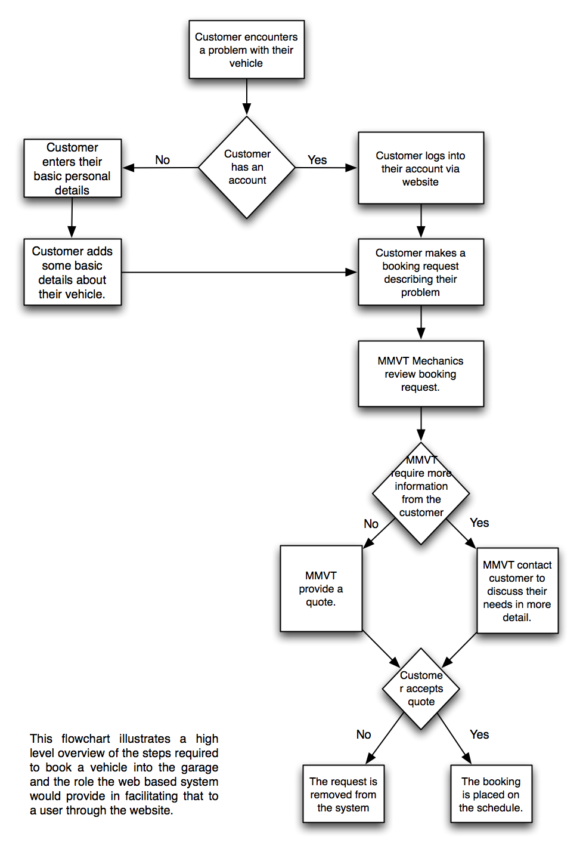
Flow diagrams have been employed to model the flow of the fundamental scenarios that the system is intended to support. In this exercise a greater understanding of the role the system plays within the scenario and what is required in order to facilitate that role.

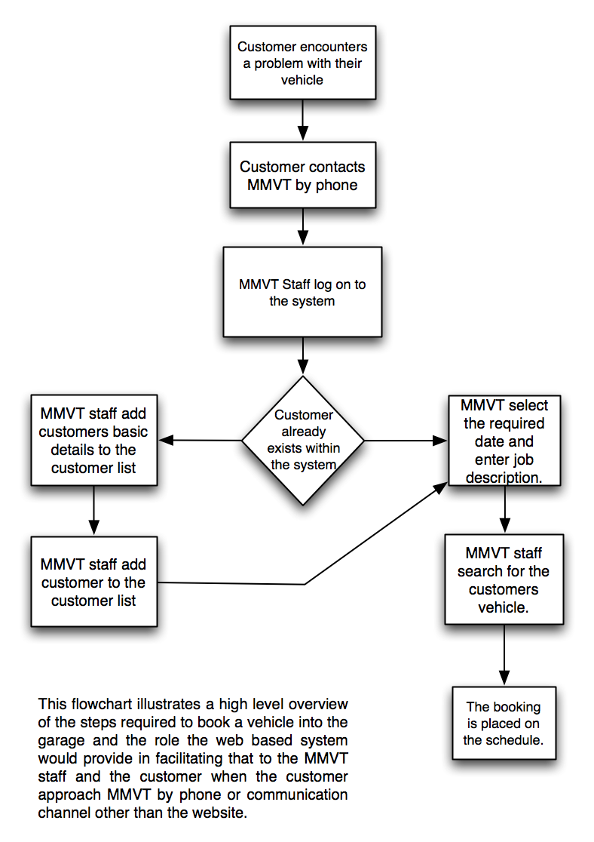

One of the things evident in the first of these flow models is that there is a element of awkwardness surrounding the quote. It requires several transactions of information between the user and the business where in some cases time may be of importance.

It is unlikely that business staff would be able to continuously monitor the request of a quote and the response the customer gives after receiving the quote if this is achieved through the system. In the initial meeting the staff expressed that they did not want to provide automated quotes and that personal attention would be required to provide a quote as well as confirm whether or not a booking could be achieved at the requested time. It was stated that in many situations additional information would be required and that they would often like to contact the customer before committing to anything.

This presents a dilemma where using the system to provide a channel of communication between the customer and the business with several transactions may reduce the efficiency at which they can be achieved.

User Evaluation

The user evaluation that we carried out came rather late in the project due to the need to have a working prototype available to test alongside requiring ethical permission to test the software system with members of the class. When both a prototype was created with the functionality needed and ethical permission was granted to test the system a user test document was produced that each of us used to evaluation the system. This document consisted of 8 activities the user was to perform without the aid or guidance of anyone outside the project however 2 of these activities did not work at the time due to a bug in the database that was resolved after testing. Each activity was broken down into the time it has taken to complete the task, what mistakes the user made whilst trying to perform the task and general comments and observations we found whilst observing the user interact with the system. Our findings from the user evaluation would have greatly aided us in improving the system given we had more time to implement these changes.

Activity 1
From the first activity we wanted to see if a user could log into the system using an account we had given them and enter their personal details and save them. From this test we discovered that there was a little confusion over if user names were case sensitive and the validation of data in the personal details form. The issue of case sensitive user names could be addressed when a user registers for an account as during this stage it could be made clear that user names will be case sensitive however in addition to this validation and feedback to the user would be beneficial in aiding them with successfully logging in without making mistakes. We were also able to identify an issue with the save button that had previously worked and that now contained a bug in which it did not display the personal details being updated correctly.

Activity 2
The next task was for the user to to add a vehicle to a customer account. An issue we identified was that the most people expected the drop down list for model to update based upon what manufacturer they selected. In addition to this we also identified an issue with our model table where the results were populating the drop down list multipliable times and this caused some confusion as to if there was any difference between these models. The average time was approximately 1 minute to add a new vehicle without guidance however there was no other problems that the user entered however the lack of validation could cause the form to crash and is something that would need to be added to avoid issues when adding invalid registration numbers, non unique licence numbers and mileage that exceeds the limit.

Activity 3
A customer making a booking for the 31st of March at 12:00 pm was a task that was completed without any issues. Unlike in activity 4 where the time was entered manually in this form the time is a drop down list that the user selects from and this solves the validation issues that we faced when making a booking on the staff side.

Activity 4
Making a booking for a customer using a staff account was on of the activities that did not cause too many problems other than confusion over what the time format should be. To address this issue it should be made clear that the time format is in 24 hours format or to provide a drop down list for hours and minutes that the user can select from to get a valid time alongside this validation is also needed to ensure only valid times are entered into this field.

Activity 5
Finding a customer who owns a vehicle with a specific registration number was completed by all users without encountering any problems in under 1 minute for each user. Users used a key supplied to us however in a working environment errors are likely to be made such as an incomplete registration number or a registration number that is too long, for these instances we should address it by providing validation and feedback when these errors occur and feedback on screen when no registration numbers with that value are found.

Activity 6
Updating the mileage of a vehicle was completed without any problems but an underlying problem in the code is that mileage cannot exceed a certain value so validation is needed to ensure this problem does not become an issue.

Conclusion of user evaluation
After our user testing we managed to resolve some of the bugs that stopped us from being able to perform addition tests we had planned on the staff pages. These pages had been working up to a few days before however they failed to work after inserting new dummy data and a problem with a foreign key holding a record that did not exist elsewhere in the table. User testing brought this issue to our attention and we quickly managed to solve it before the deadline for the project however given more time additional user testing would be needed for the revised prototype and though each iteration until the prototype is made into a fully functionality and working software system. In addition to this user validation and feedback to the user is needed in the prototype as it is one of the issues we have identified whilst user testing. The addition of this would greatly improve the usability of the software system and reduce on the bugs we discovered during testing.

